Perinatal Mental Health Social Prescribing Link Worker- Kirkby Primary Care Network
Deadline for application 12 noon on Friday 16th February 2024

Foreword from the CEO

Dear applicant,
One Knowsley is the strategic place lead for the VCFSE sector in the borough; driving forward the Knowsley Better Together principles to secure a shared vision for Knowsley 2030. We work closely with public and private sector strategic partners (including those involved in healthcare transformation) to represent the interests of the VCFSE sector. We are delighted you are considering joining a collaborative and supportive team who are passionate about supporting and developing the voluntary, community, faith and social enterprise (VCFSE) sector in Knowsley.

If you feel you have the attitudes, skills and experience to work with us to deliver our vision, send your C.V. plus a personal statement - clearly indicating how you meet the person and role specification, to Debbie.Bennett@oneknowsley.org by 12 noon on Friday 16th February 2024.
Applicants shortlisted for interview will be notified by close of play on Monday 19th February 2024.
Interviews will be held in person Monday 26th February 2024.
Best wishes

Debbie Bennett
Health & Care Transformation Manager

History
One Knowsley is the independent social infrastructure support body for Voluntary, Community, Faith and Social Enterprise organisations, also collectively known as the Social Sector or Third Sector, within the borough of Knowsley.
One Knowsley evolved out of Knowsley Community and Voluntary Services (KCVS), which in turn came out of Huyton with Roby Council for Social Service (HCSS) which was inaugurated in 1963 to provide support to local volunteers and establish local responses to local need. In 1974 the district authority of Knowsley was created.
The CVS movement
The CVS movement, also known as Local Infrastructure Organisations (LIOs), provide coordination and support for ‘frontline’ VCFSE sector groups and organisations in their areas.
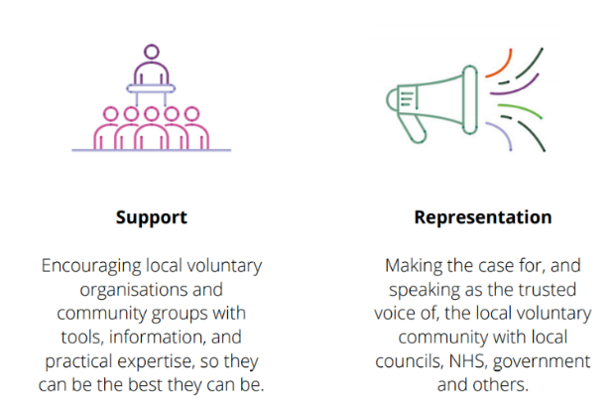
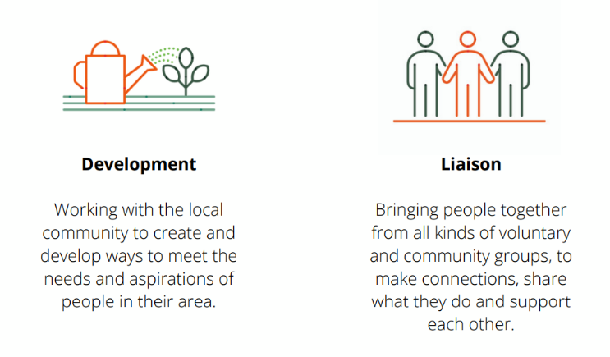
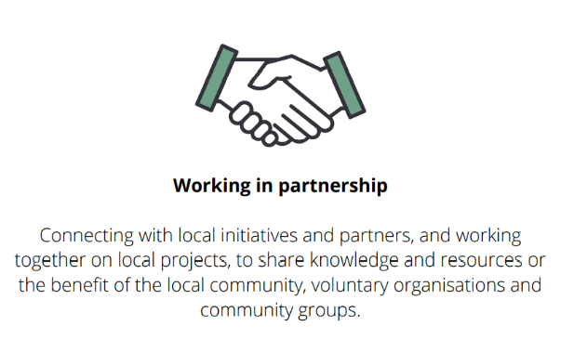

One Knowsley’s Vision
A resilient, sustainable, and vibrant Social Sector which is collaborative and self-supporting

Our Values
Insight – harnessing information, knowledge, and experience
Authenticity – keeping it real, relevant, and rooted in Knowsley
Boldness – having the courage to be brave, be objective, be leaders and get the job done

Who we are?
One Knowsley’s Charitable Objects and Public Benefit are;
The promotion of all or any charitable purposes for the benefit of the community in the area of the metropolitan district of Knowsley and surrounding areas (hereinafter called “the area of benefit”) and in particular by assisting the work of statutory authorities and voluntary organisations engaged in the advancement of education, promoting health, relieving poverty, and sickness or in pursing any other objects which now or hereafter may be deemed by law to be charitable.
Charitable activities as summarised by Trustees and registered with the Charity Commission are;
- To enhance the quality of life within communities and neighbourhoods by supporting and developing voluntary action in the borough of Knowsley.
- To support and develop the work of voluntary and community organisations.
- To provide and circulate information relevant to the work of voluntary and community groups.
- To act as a focal point and resource for voluntary and community groups.
A Board of Directors govern the charitable company and for the purposes of charitable law are known as Trustees.
One Knowsley is a registered charity regulated by the Charity Commission Registered Charity Number 701955 and a Company Limited by Guarantee Registered in England and Wales, Company Number 2401660. The company does not have share capital. Regulation drives the standards of governance adopted by One Knowsley to maintain compliance with the regulator with financial governance aligned to the charities governing document, the Companies Act 2006 and FRS 102 Charities Statement of Recommended Practice (SORP).

Core Competencies
All members of the One Knowsley team are expected to demonstrate the following core competencies, please note that the level that these are required for each role are detailed further in the individual person specification.

Committed to One Knowsley’s mission, values, and operational approach
Able and willing to work collaboratively in a team, taking a lead where necessary
Adept at building and maintaining effective relationships with VCFSE and a varied range of external partners
Excellent written and verbal communication skills including listening
Excellent record keeping skills
Digitally enthusiastic, IT literate and able to use social media and related communication tools and systems
Demonstrable agility and an ability to work on several (often competing) activities/tasks/projects simultaneously
Excellent at finding solutions and problem solving
Able to represent One Knowsley to internal and external stakeholders with authority, calmness, and expertise
Able and willing to be self-supporting in terms of administrative tasks
Willing to work in a small team and support and substitute for colleagues, adopting the shared responsibilities for each team member

Information specific to the post

Job title | Perinatal Mental Health Social Prescribing Link Worker (Kirkby PCN)
Salary | £25,500 per annum
Benefits: | Generous leave allowance, flexible working, pension contribution.
Location | Court Hey Park/ Kirkby Area/Hybrid working
Hours of Work | 35 Hours per week (worked flexibly with a requirement for evening and weekend work when required by the post).
Accountable to | Health & Care Transformation Manager

Purpose of the Role
Social prescribing empowers people to take control of their health and wellbeing through referral to non-medical ‘link workers’ who give time, focus on ‘what matters to me’ and take a holistic approach, connecting people to community groups and statutory services for practical and emotional support. Link workers support existing groups to be accessible and sustainable and help people to start new community groups, working collaboratively with all local partners.

Social prescribing can help to strengthen community resilience and personal resilience and reduces health inequalities by addressing the wider determinants of health, such as debt, poor housing and physical inactivity, by increasing people’s active involvement with their local communities. It particularly works for people with long-term conditions (including support for mental health), for people who are lonely or isolated, or have complex social needs which affect their wellbeing.

Key Responsibilities and Tasks

- Take referrals from a wide range of healthcare staff, working within Kirkby GP practices within primary care networks and multi – disciplinary teams.

- Provide personalised support to individuals, their families, and carers to take control of their wellbeing, live independently and improve their health outcomes. Develop trusting relationships by giving people time and focus on ‘what matters to me’. Take a holistic approach, based on the person’s priorities and the wider determinants of health. Co-produce a personalised support plan to improve health and wellbeing, introducing or reconnecting people to community groups and statutory services. The role will require managing and prioritising your own caseload, in accordance with the needs, priorities and any urgent support required by individuals on the caseload. It is vital that you have a strong awareness and understanding of when it is appropriate or necessary to refer people back to other health professionals/agencies, when what the person needs is beyond the scope of the link worker role – e.g. when there is a mental health need requiring a qualified practitioner.

- Draw on and increase the strengths and capacities of local communities, enabling local VCFSE organisations and community groups to receive social prescribing referrals. Ensure they are supported, have basic safeguarding processes for vulnerable individuals and can provide opportunities for the person to develop friendships, a sense of belonging, and build knowledge, skills and confidence.
- Work together with all local partners to collectively ensure that local VCFSE organisations and community groups are sustainable and that community assets are nurtured, by making them aware of small grants or micro-commissioning if available, including providing support to set up new community groups and services, where gaps are identified in local provision. Establish a Perinatal Community of Practice.

Referrals
- Promoting social prescribing, its role in self-management, and the wider determinants of health.
- Build relationships with key staff in GP practices within the local Primary Care Network (PCN), attending relevant meetings, becoming part of the wider network team, giving information and feedback on social prescribing.
- Be proactive in developing strong links with all local agencies to encourage referrals, recognising what they need to be confident in the service to make appropriate referrals.
- Work in partnership with all local agencies to raise awareness of social prescribing and how partnership working can reduce pressure on statutory services, improve health outcomes and enable a holistic approach to care.
- Provide referral agencies with regular updates about social prescribing, including training for their staff and how to access information to encourage appropriate referrals.
- Seek regular feedback about the quality of service and impact of social prescribing on referral agencies.
- Be proactive in encouraging self-referrals and connecting with all local communities, particularly those communities that statutory agencies may find hard to reach.

Provide Personalised Support
- Meet people on a one-to-one basis, making home visits where appropriate within One Knowsley’s policies and procedures. Give people time to tell their stories and focus on ‘what matters to me’. Build trust with the person, providing non- judgemental support, respecting diversity and lifestyle choices. Work from a strength-based approach focusing on a person’s assets.
- Be a friendly source of information about wellbeing and prevention approaches.
- Help people identify the wider issues that impact on their health and wellbeing, such as debt, poor housing, being unemployed, loneliness and caring responsibilities.
- Work with the person, their families and carers and consider how they can all be supported through social prescribing.
- Help people maintain or regain independence through living skills, adaptations, enablement approaches and simple safeguards.
- Work with individuals to co-produce a simple personalised support plan – based on the person’s priorities, interests, values and motivations – including what they can expect from the groups, activities and services they are being connected to and what the person can do for themselves to improve their health and wellbeing.
- Where appropriate, physically introduce people to community groups, activities and statutory services, ensuring they are comfortable. Follow up to ensure they are happy, able to engage, included and receiving good support.
- Where people may be eligible for a personal health budget, help them to explore this option as a way of providing funded, personalised support to be independent, including helping people to gain skills for meaningful employment, where appropriate

Support community groups and VCFSE organisations to receive referrals
- Forge strong links with local VCFSE organisations, community and neighbourhood level groups, utilising their networks and building on what’s already there. Use these opportunities to promote micro-commissioning or small grants if available.
- Develop supportive relationships with local VCFSE organisations, community groups and statutory services, to make timely, appropriate and supported referrals for the person being introduced. Establish a Perinatal Community of Practice.
- Ensure that local community groups and VCFSE organisations being referred to, have basic procedures in place for ensuring that vulnerable individuals are safe and, where there are safeguarding concerns, work with all partners to deal appropriately with issues. Where such policies and procedures are not in place, support groups to work towards this standard before referrals are made to them.
- Check that community groups and VCFSE organisations meet in insured premises and that health and safety requirements are in place. Where such policies and procedures are not in place, support groups to work towards this standard before referrals are made to them.
- Support local groups to act in accordance with information governance policies and procedures, ensuring compliance with the Data Protection Act.

Work collectively with all local partners to ensure community groups are strong and sustainable
- Work with commissioners and local partners to identify unmet needs within the community and gaps in community provision.
- Support local partners and commissioners to develop new groups and services where needed, through small grants for community groups, micro-commissioning and development support.
- Encourage people who have been connected to community support through social prescribing to volunteer and give their time freely to others, in order to build their skills and confidence, and strengthen community resilience.
- Encourage people, their families and carers to provide peer support and to do things together, such as setting up new community groups or volunteering.
- Provide a regular ‘confidence survey’ to community groups receiving referrals, to ensure that they are strong, sustained and have the support they need to be part of social prescribing.

General tasks
Data capture
- Work sensitively with people, their families and carers to capture key information, enabling tracking of the impact of social prescribing on their health and wellbeing.
- Encourage people, their families and carers to provide feedback and to share their stories about the impact of social prescribing on their lives.
- Support referral agencies to provide appropriate information about the person they are referring. Use the case management system to track the person’s progress. Provide appropriate feedback to referral agencies about the people they referred.
- Work closely with GP practices within the PCN to ensure that social prescribing referral codes are inputted to EMIS/Elemental Software systems and that the person’s use of the NHS can be tracked, adhering to data protection legislation and data sharing agreements with the Integrated Care Boards.

Professional development
- Work with your line manager to undertake continual personal and professional development, taking an active part in reviewing and developing the roles and responsibilities.
- Adhere to organisational policies and procedures, including confidentiality, safeguarding, lone working, information governance, and health and safety.

Miscellaneous
- Work as part of the team to seek feedback, continually improve the service and contribute to business planning. Support team members where capacity becomes an issue.
- Undertake any tasks consistent with the level of the post and the scope of the role, ensuring that work is delivered in a timely and effective manner.
- Duties may vary from time to time, without changing the general character of the post or the level of responsibility.

Person Specification

Criteria |  | Essential | Desirable
Personal Qualities and Attributes | Ability to listen, empathise with people and provide person centred support in a non-judgemental way | ✓
 | Able to get along with people from all backgrounds and communities, respecting lifestyles and diversity | ✓
 | Commitment to reducing health inequalities and proactively working to reach people from all communities | ✓
 | Able to support people in a way that inspires trust and confidence, motivating others to reach their potential | ✓
 | Ability to communicate effectively, both verbally and in writing, with people, their families, carers, community groups, partner agencies and stakeholders | ✓
 | Have a strong awareness and understanding of when it is appropriate or necessary to refer people back to other health professionals/agencies, when what the person needs is beyond the scope of the link worker role – e.g. when there is a mental health need requiring a qualified practitioner. | ✓
 | Able to work from an asset-based approach, building on existing community and personal assets | ✓
 | Able to provide leadership and to finish work tasks | ✓
 | Ability to maintain effective working relationships and to promote collaborative practice with all colleagues | ✓
 | Commitment to collaborative working with all local agencies (including VCFSE organisations and community groups). Able to work with others to reduce hierarchies and find creative solutions to community issues | ✓
Qualifications and Training | NVQ Level 3, Advanced level or equivalent qualifications or working towards | ✓
 | Training in motivational coaching and interviewing or equivalent experience | ✓
 | Demonstrable commitment to professional and personal development. |  | ✓
 | Training in Early Years development | ✓
 | Training in Perinatal Mental Health |  | ✓
Experience | Experience of working directly in a community development context, adult health and social care, learning support or public health/health improvement (including unpaid work) | ✓
 | Experience of supporting perinatal mums and their families and carers in a related role (including unpaid work) | ✓
 | Experience of supporting people with their mental health, either in a paid, unpaid or informal capacity | ✓
 | Experience of working with the VCSE sector (in a paid or unpaid capacity), including with volunteers and small community groups | ✓
 | Experience of data collection and providing monitoring information to assess the impact of services |  | ✓
 | Experience of partnership/collaborative working and of building relationships across a variety of organisations | ✓
Skills and  Knowledge | Knowledge of the personalised care approach |  | ✓
 | Understanding of the wider determinants of health, including social, economic and environmental factors and their impact on communities | ✓
 | Knowledge of community development approaches and Children and Young people’s services | ✓
 | Knowledge of IT systems, including ability to use word processing skills, emails and the internet to create simple plans and reports | ✓
 | Knowledge of motivational coaching and interview skills. | ✓
 | Knowledge of VCFSE and community services in the locality |  | ✓
Other | Meets DBS reference standards, relevant to the post and in line with the law | ✓
 | Willingness to work flexible hours when required to meet work demands | ✓
 | A full driving licence and access to own transport, and willingness to travel across the locality when required | ✓

General
The post-holder will be required to confirm their eligibility to work in the UK in order to comply with employment legislation.

Confidentiality
The post-holder must maintain the confidentiality of all information and records relating to the work of One Knowsley, in accordance with the organisation’s procedures and policies.

Hours of Work
The role is 35 hours per week, usually worked 9-5 Monday to Friday however the post-holder must be prepared to work flexible hours, in line with the requirements of the post. This may involve some evening and occasional weekend work, for which time off in lieu will be granted, subject to One Knowsley policies and procedures and prior agreement with the line manager. The post-holder will be expected to adopt a mature and common-sense approach to this arrangement.

Pension
A Pension scheme is in operation and One Knowsley contributes 5% on behalf of all employees who have opted to join the scheme.

Annual Leave & Public Holidays
Annual leave entitlement is 25 days leave plus normal Bank & Public Holidays (pro rata for part time posts). This increases by one day per year up to a maximum of 30 days leave. The organisation reserves the right to close over the Christmas period. Employees are required to reserve the required amount of their holiday entitlement to cover these days.

Travel & Other Expenses
Reasonable expenses incurred in the course of duty will be reimbursed on receipt of a completed One Knowsley Expenses Claim Form.

Other Employee Benefits
Medicash Proactive – A company funded health plan including optical, dental and physiotherapy treatments. Employees can also access additional benefits such as discounted gym membership.
Group Life assurance which provides a tax free payment of 3 x annual salary, on the death of an employee, to their nominated beneficiary.

Equal Opportunities
One Knowsley is committed to equal opportunities, anti-discrimination and anti-oppressive policy and practice. No one we have contact with may be discriminated against either directly or indirectly on the grounds of gender, race, nationality, religion, cultural group, marital status, sexual orientation, age, or impairment.

Disability Confident Employer
One Knowsley have been awarded the Disability Confident Employer accreditation (previously Disability Two Ticks) in recognition of our commitment to the recruitment, employment, retention, and career development of disabled people.
One Knowsley will work with individuals and others, where appropriate, to identify what reasonable adjustments can be made to accommodate access needs.
Although every attempt is made to meet the access needs of disabled people, it cannot always be guaranteed that every individual need will be met. For example, it may be necessary for the post-holder to attend meetings in buildings outside the normal operational base where unimpaired access to such premises cannot be guaranteed.

What we mean by disability
The Equality Act 2010 defines a disabled person as someone who has a physical or mental impairment that has a substantial and long-term adverse effect on their ability to carry out normal day-to-day activities.

Guaranteed Interview
The Disability Confident Employer accreditation includes a guaranteed interview for any disabled applicant who meets the common and specific requirements for a job.

How to apply
If you feel you are eligible for a guaranteed interview under the Disability Confident scheme, please complete and return the form found at the end of this document.

Additional information to all candidates
Thank you for your interest in joining the team at One Knowsley.
If you have not heard from us by close of business on Monday 19th February 2024, you have not been shortlisted on this occasion. Unfortunately, we are unable to provide feedback to applicants who do not progress to interview.
Closing Date: 12 noon on Friday 16th February 2024.
Interview Date: Monday 26th February 2024.

Guaranteed Interview: The Disability Confident Employer accreditation includes a guaranteed interview for any disabled applicant who meets the common and specific requirements for a job.
How to apply
Simply complete the information requested below, sign the declaration, and attach it with your application.
Do you require any reasonable adjustments at interview?  (delete as appropriate) | Yes/No

If you answered Yes to the previous question, please give details below:
* Any information you give will be treated in confidence.

Declaration
I consider myself to have a disability as defined above and I would like to apply under the Guaranteed Interview Scheme.
Name
Date
Signature

Any false declaration of disability to obtain an interview will subsequently invalidate any contract of employment.

Email: info@oneknowsley.org
Phone: 0151 489 1222
Website: oneknowsley.org
One Knowsley, Registered Charity No 701955
Limited by Guarantee Registered in England and Wales
Registered Company No 2401660
One Knowsley, The Courtyard, Court Hey Park, Roby Road, Huyton, Knowsley, L16 3NA

