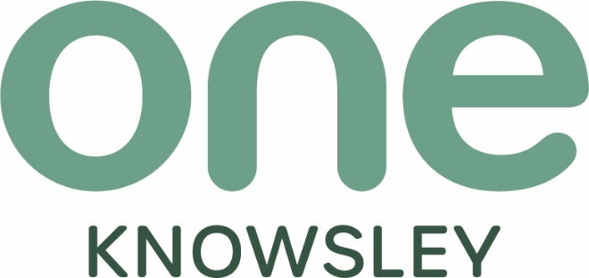

Chief Operating Officer (COO)

Closing date midnight on Friday 6th September 2024






Dear Applicant,
Thank you for your interest in joining One Knowsley. One Knowsley is the strategic place lead for the Voluntary, Community, Faith and Social Enterprise (VCFSE) sector in the borough; driving forward the Knowsley Better Together principles to secure a shared vision for Knowsley 2030.

Where strong and safe communities can shape their future
Where people are active and healthy and have access to the support they need
Where people of all ages are confident and can achieve their full potential
With a thriving, inclusive economy with opportunities for people and business
With welcoming, vibrant neighbourhoods and town centres
Achieving Net Zero

One Knowsley’s vision is a resilient, vibrant and collaborative VCFSE sector
Our mission is to:

Champion the VCFSE sector – ensuring its voice is heard and understood at strategic level.
Connect VCFSE organisations to; each other, decision makers, funders, commissioners and opportunities for collaboration.
Convene key strategic conversations that push forward an enabling policy environment, connecting VCFSE interests with public sector and private sectors
Empower VCFSE organisations with access to trusted advice, information, guidance, insights, support, development and funding.
Mobilise community action and engagement through its volunteer centre, VCFSE networks, Alliances and Forums

If you feel you have the attitudes, skills and experience to work with us to deliver our vision, send your C.V. plus a personal statement - clearly indicating how you meet the person and role specification to recruitment@oneknowsley.org clearly stating the role you are applying for in the subject title by midnight on Friday 6th September 2024.

Applicants shortlisted for interview will be notified week commencing Monday 9th September 2024.

Interviews will be held in person at One Knowsley, Court Hey L16 3NA
on either Wednesday 18th or Thursday 19th September 2024
(successfully shortlisted candidates will be notified which day nearer the time).

Kind regards, we look forward to receiving your application

Racheal Jones FRSA CEO
History
One Knowsley is the independent social infrastructure support body for Voluntary, Community, Faith and Social Enterprise organisations, also collectively known as the Social Sector or Third Sector, within the borough of Knowsley.
One Knowsley evolved out of Knowsley Community and Voluntary Services (KCVS), which in turn came out of Huyton with Roby Council for Social Service (HCSS) which was inaugurated in 1963 to provide support to local volunteers and establish local responses to local need. In 1974 the district authority of Knowsley was created.
The CVS movement
The CVS movement, also known as Local Infrastructure Organisations (LIOs), provide coordination and support for ‘frontline’ VCFSE sector groups and organisations in their areas.
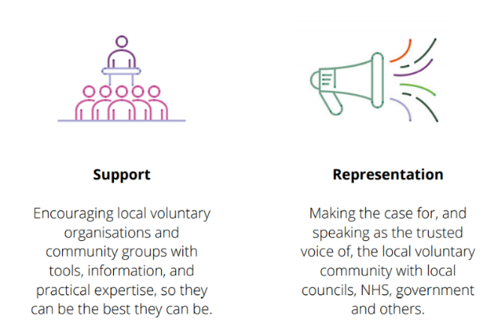
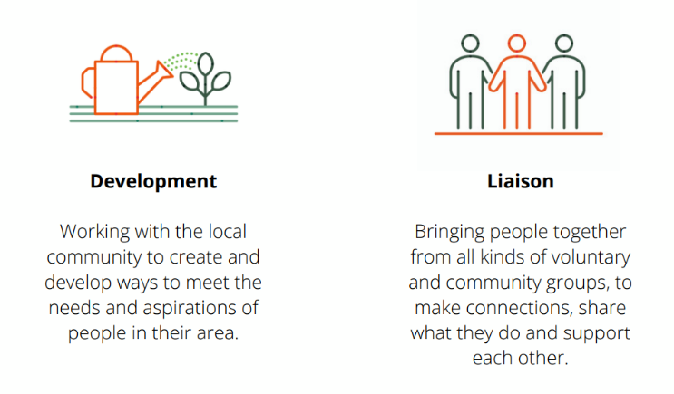
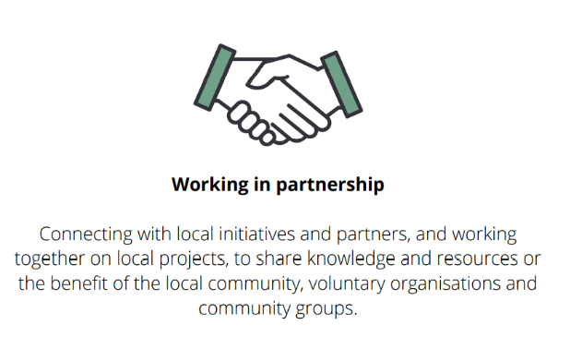

One Knowsley’s Vision
A resilient, sustainable, and vibrant Social Sector which is collaborative and self-supporting

Our Values
Insight – harnessing information, knowledge, and experience
Authenticity – keeping it real, relevant, and rooted in Knowsley
Boldness – having the courage to be brave, be objective, be leaders and get the job done

Who we are?
One Knowsley’s Charitable Objects and Public Benefit are;
The promotion of all or any charitable purposes for the benefit of the community in the area of the metropolitan district of Knowsley and surrounding areas (hereinafter called “the area of benefit”) and in particular by assisting the work of statutory authorities and voluntary organisations engaged in the advancement of education, promoting health, relieving poverty, and sickness or in pursing any other objects which now or hereafter may be deemed by law to be charitable.
Charitable activities as summarised by Trustees and registered with the Charity Commission are;
- To enhance the quality of life within communities and neighbourhoods by supporting and developing voluntary action in the borough of Knowsley.
- To support and develop the work of voluntary and community organisations.
- To provide and circulate information relevant to the work of voluntary and community groups.
- To act as a focal point and resource for voluntary and community groups.
A Board of Directors govern the charitable company and for the purposes of charitable law are known as Trustees.
One Knowsley is a registered charity regulated by the Charity Commission Registered Charity Number 701955 and a Company Limited by Guarantee Registered in England and Wales, Company Number 2401660. The company does not have share capital. Regulation drives the standards of governance adopted by One Knowsley to maintain compliance with the regulator with financial governance aligned to the charities governing document, the Companies Act 2006 and FRS 102 Charities Statement of Recommended Practice (SORP).

Core Competencies
All members of the One Knowsley team are expected to demonstrate the following core competencies, please note that the level that these are required for each role are detailed further in the individual person specification.

- Committed to One Knowsley’s mission, values, and operational approach
- Able and willing to work collaboratively in a team, taking a lead where necessary
- Adept at building and maintaining effective relationships with VCFSE and a varied range of external partners
- Excellent written and verbal communication skills including listening
- Excellent record keeping skills
- Digitally enthusiastic, IT literate and able to use social media and related communication tools and systems
- Demonstrable agility and an ability to work on several (often competing) activities/tasks/projects simultaneously
- Excellent at finding solutions and problem solving
- Able to represent One Knowsley to internal and external stakeholders with authority, calmness, and expertise
- Able and willing to be self-supporting in terms of administrative tasks
Willing to work in a small team and support and substitute for colleagues, adopting the shared responsibilities for each team member

Information specific to the post

Job title | Chief Operating Officer (COO)
Salary | £42,000 per annum
Benefits: | Generous leave allowance, flexible working, pension contribution.
Location | Court Hey Park/Hybrid working
Hours of Work | 35 Hours per week (worked flexibly with a requirement for evening and weekend work when required by the post).
Accountable to | Chief Executive Officer (CEO)
Direct Reports | Senior Managers and Officers

Purpose of the Role
The Chief Operating Officer (COO) will play a pivotal role in ensuring the effective and efficient operation of
One Knowsley, working closely with the CEO. The COO will be responsible for the operational management of the organisation, driving strategic initiatives forward into delivery, ensuring resilience and financial sustainability, and overseeing the day-to-day administration of the organization. This role demands a leader who is both operationally and strategically astute, with a deep commitment to One Knowsley’s vision, mission and strategic plan.

Key responsibilities

1. Operational Leadership:
- Oversee the daily operations of the charity, ensuring alignment with the strategic goals.
- Implement and monitor systems, processes, and policies that foster an effective and efficient organisational environment.
- Lead and manage service delivery leads to ensure they are delivering on their operational objectives.

2. Strategic Planning:
- Work closely with the CEO to develop and implement the organisations strategic plan.
- Translate strategic objectives into operational plans with clear deliverables and timelines.
- Monitor and report on the progress of strategic initiatives, adjusting plans as necessary.

3. Financial Management:
- Oversee the financial scope of delivery activity to ensure programmes and projects are delivered on time and within budget whilst ensuring optimal allocation of resources.
- Work with the finance team to monitor financial performance, manage risks, and report to the CEO.

4. Human Resources Management:
- Lead on HR policies and practices, ensuring a positive organisational culture and high levels of staff engagement.
- Oversee talent management including recruitment, training, development, and performance management.
- Ensure One Knowsley is compliant with employment laws and best practices.

5. Governance and Compliance:
- Ensure compliance with all relevant legal and regulatory requirements.
- Work with the CEO to support the Board of Trustees, providing them with timely and accurate information.
- Develop and implement risk management strategies.

6. Stakeholder Engagement:
- Build and maintain relationships with key stakeholders, including funders, partners, and regulatory bodies.
- Represent One Knowsley externally to enhance its public profile and secure necessary support.

7. Innovation and Development:
- Identify opportunities for innovation and growth within One Knowsley’s delivery and operations.
- Lead on the development of new projects and initiatives that align with the charity’s mission.

Person Specification

Criteria |  | Essential | Desirable
Personal Qualities and Attributes | Demonstrated ability to lead, manage, and develop teams. | ✓
 | Exceptional communication skills, both verbal and written, with the ability to engage and influence a wide range of stakeholders. | ✓
 | Strong financial acumen with experience managing budgets, financial planning, and risk management. | ✓
Qualifications and Training | Relevant qualification in business administration. |  | ✓
 | Proven experience in a senior operational leadership role, preferably within the charity or non-profit sector. | ✓
 | Demonstrable commitment to professional and personal development. | ✓
Experience | Strong understanding of governance and compliance within a charity context. | ✓
 | Experience in strategic planning and implementation with the ability to translate strategy into actionable plans. | ✓
 | Experience in fundraising and developing new income streams. | ✓
Skills and  Knowledge | Knowledge of the Voluntary, Community, Faith, and Social Enterprise (VCFSE) sector and its challenges | ✓
 | Excellent project and program management skills with a track record of delivering complex initiatives. | ✓
 | Proficiency in digital tools and an ability to champion the use of technology within the organisation. | ✓
Other | Willingness to work flexible hours when required to meet work demands | ✓
 | A full driving licence and access to own transport, and willingness to travel across the locality when required | ✓

Core Competencies
- Committed to the charity’s mission, values, and operational approach.
- Strategic thinker with the ability to see the bigger picture while also focusing on operational details.
- Collaborative and able to work effectively within a team, taking a leadership role when necessary.
- Resilient and adaptable, with the ability to manage competing priorities in a complex environment.
- Entrepreneurial and innovative, with a proactive approach to problem-solving
This is a flexible job description that may evolve with the needs of the organisation.
Professional development
- Work with your line manager to undertake continual personal and professional development, taking an active part in reviewing and developing the roles and responsibilities.
- Adhere to organisational policies and procedures, including confidentiality, safeguarding, lone working, information governance, and health and safety.

Miscellaneous
- Work as part of the team to seek feedback, continually improve the service and contribute to business planning. Support team members where capacity becomes an issue.
- Undertake any tasks consistent with the level of the post and the scope of the role, ensuring that work is delivered in a timely and effective manner.
- Duties may vary from time to time, without changing the general character of the post or the level of responsibility.

General
The post-holder will be required to confirm their eligibility to work in the UK in order to comply with employment legislation.

Confidentiality
The post-holder must maintain the confidentiality of all information and records relating to the work of One Knowsley, in accordance with the organisation’s procedures and policies.

Hours of Work
The role is 35 hours per week, usually worked 9-5 Monday to Friday however the post-holder must be prepared to work flexible hours, in line with the requirements of the post. This may involve some evening and occasional weekend work, for which time off in lieu will be granted, subject to One Knowsley policies and procedures and prior agreement with the line manager. The post-holder will be expected to adopt a mature and common-sense approach to this arrangement.

Pension
A Pension scheme is in operation and One Knowsley contributes 5% on behalf of all employees who have opted to join the scheme.

Annual Leave & Public Holidays
Annual leave entitlement is 25 days leave plus normal Bank & Public Holidays (pro rata for part time posts). This increases by one day per year up to a maximum of 30 days leave. The organisation reserves the right to close over the Christmas period. Employees are required to reserve the required amount of their holiday entitlement to cover these days.

Travel & Other Expenses
Reasonable expenses incurred in the course of duty will be reimbursed on receipt of a completed One Knowsley Expenses Claim Form.

Other Employee Benefits
Medicash Proactive – A company funded health plan including optical, dental and physiotherapy treatments. Employees can also access additional benefits such as discounted gym membership.
Group Life assurance which provides a tax free payment of 3 x annual salary, on the death of an employee, to their nominated beneficiary.

Equal Opportunities
One Knowsley is committed to equal opportunities, anti-discrimination and anti-oppressive policy and practice. No one we have contact with may be discriminated against either directly or indirectly on the grounds of gender, race, nationality, religion, cultural group, marital status, sexual orientation, age, or impairment.

Disability Confident Employer
One Knowsley have been awarded the Disability Confident Employer accreditation (previously Disability Two Ticks) in recognition of our commitment to the recruitment, employment, retention, and career development of disabled people.
One Knowsley will work with individuals and others, where appropriate, to identify what reasonable adjustments can be made to accommodate access needs.
Although every attempt is made to meet the access needs of disabled people, it cannot always be guaranteed that every individual need will be met. For example, it may be necessary for the post-holder to attend meetings in buildings outside the normal operational base where unimpaired access to such premises cannot be guaranteed.

What we mean by disability
The Equality Act 2010 defines a disabled person as someone who has a physical or mental impairment that has a substantial and long-term adverse effect on their ability to carry out normal day-to-day activities.

Guaranteed Interview
The Disability Confident Employer accreditation includes a guaranteed interview for any disabled applicant who meets the common and specific requirements for a job.

How to apply
If you feel you are eligible for a guaranteed interview under the Disability Confident scheme, please complete and return the form found at the end of this document.

Additional information to all candidates
Thank you for your interest in joining the team at One Knowsley.
If you have not heard from us within 4 weeks, you have not been shortlisted on this occasion. Unfortunately, we are unable to provide feedback to applicants who do not progress to interview.


Guaranteed Interview: The Disability Confident Employer accreditation includes a guaranteed interview for any disabled applicant who meets the common and specific requirements for a job.
How to apply
Simply complete the information requested below, sign the declaration, and attach it with your application.
Do you require any reasonable adjustments at interview?  (delete as appropriate) | Yes/No

If you answered Yes to the previous question, please give details below:
* Any information you give will be treated in confidence.

Declaration
I consider myself to have a disability as defined above and I would like to apply under the Guaranteed Interview Scheme.
Name
Date
Signature

Any false declaration of disability to obtain an interview will subsequently invalidate any contract of employment.

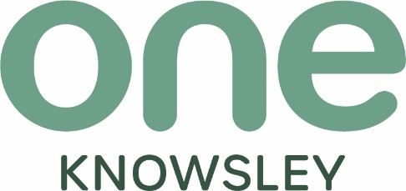

Email: info@oneknowsley.org
Phone: 0151 489 1222
Website: oneknowsley.org
One Knowsley, Registered Charity No 701955
Limited by Guarantee Registered in England and Wales
Registered Company No 2401660
One Knowsley, The Courtyard, Court Hey Park, Roby Road, Huyton, Knowsley, L16 3NA

