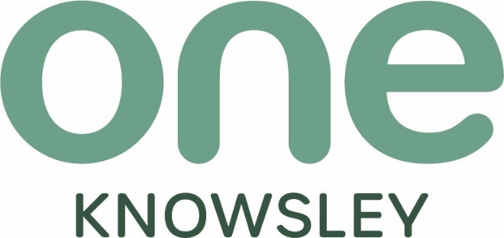


Enterprise Manager
Closing date: midnight on Sunday 16th March 2025




Dear Applicant,
Thank you for your interest in joining One Knowsley. One Knowsley is the strategic place lead for the Voluntary, Community, Faith and Social Enterprise (VCFSE) sector in the borough; driving forward the Knowsley Better Together principles to secure a shared vision for Knowsley 2030.

Where strong and safe communities can shape their future
Where people are active and healthy and have access to the support they need
Where people of all ages are confident and can achieve their full potential
With a thriving, inclusive economy with opportunities for people and business
With welcoming, vibrant neighbourhoods and town centres
Achieving Net Zero

One Knowsley’s vision is a resilient, vibrant and collaborative VCFSE sector. More information about the VCFSE sector in Knowsley is available here
If you feel you have the attitudes, skills and experience to work with us to deliver our vision, send your C.V. plus a personal statement - clearly indicating how you meet the person and role specification to recruitment@oneknowsley.org clearly stating the role you are applying for in the subject title by Midnight on Sunday 16th March 2025

Applicants shortlisted for interview will be notified week commencing 24th March 2025

Interviews will be held in person at One Knowsley, Court Hey L16 3NA week commencing 31st March 2025

Kind regards, we look forward to receiving your application

Racheal Jones FRSA
CEO

History
One Knowsley is the independent social infrastructure support body for Voluntary, Community, Faith and Social Enterprise organisations, also collectively known as the Social Sector or Third Sector, within the borough of Knowsley.
One Knowsley evolved out of Knowsley Community and Voluntary Services (KCVS), which in turn came out of Huyton with Roby Council for Social Service (HCSS) which was inaugurated in 1963 to provide support to local volunteers and establish local responses to local need. In 1974 the district authority of Knowsley was created.

The CVS movement
The CVS movement, also known as Local Infrastructure Organisations (LIOs), provide coordination and support for ‘frontline’ VCFSE sector groups and organisations in their areas.
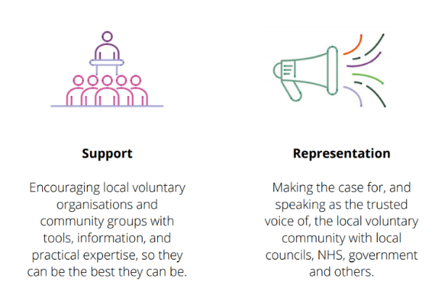
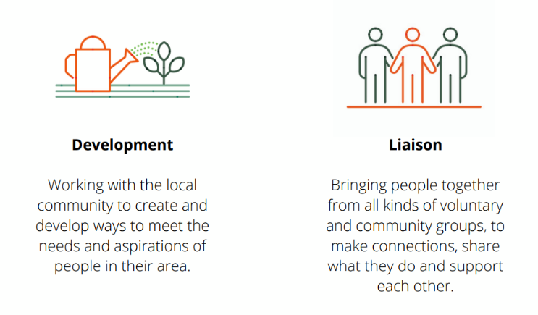
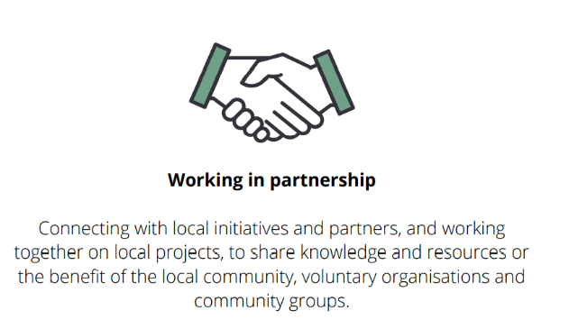

One Knowsley’s Vision
One Knowsley’s vision is a resilient, vibrant and collaborative VCFSE sector.

Our Values
Insight – harnessing information, knowledge, and experience
Authenticity – keeping it real, relevant, and rooted in Knowsley
Boldness – having the courage to be brave, be objective, be leaders and get the job done

Who we are?
One Knowsley’s Charitable Objects and Public Benefit are;
The promotion of all or any charitable purposes for the benefit of the community in the area of the metropolitan district of Knowsley and surrounding areas (hereinafter called “the area of benefit”) and in particular by assisting the work of statutory authorities and voluntary organisations engaged in the advancement of education, promoting health, relieving poverty, and sickness or in pursing any other objects which now or hereafter may be deemed by law to be charitable.
Charitable activities as summarised by Trustees and registered with the Charity Commission are;
- To enhance the quality of life within communities and neighbourhoods by supporting and developing voluntary action in the borough of Knowsley.
- To support and develop the work of voluntary and community organisations.
- To provide and circulate information relevant to the work of voluntary and community groups.
- To act as a focal point and resource for voluntary and community groups.
A Board of Directors govern the charitable company and for the purposes of charitable law are known as Trustees.
One Knowsley is a registered charity regulated by the Charity Commission Registered Charity Number 701955 and a Company Limited by Guarantee Registered in England and Wales, Company Number 2401660. The company does not have share capital. Regulation drives the standards of governance adopted by One Knowsley to maintain compliance with the regulator with financial governance aligned to the charities governing document, the Companies Act 2006 and FRS 102 Charities Statement of Recommended Practice (SORP).

Information specific to the post
Job title | Enterprise Manager
Salary | £35,000 per annum
Benefits: | Generous leave allowance, flexible working, pension contribution.
Location | One Knowsley Court Hey Park L16 3NA
Hours of Work | 35 Hours per week (worked flexibly with a requirement for evening and weekend work as required by the post).
Accountable to | Chief Operating Officer
Direct Reports | Social Impact Lead

Purpose of the Role
The Enterprise Manager will drive forward the establishment of the trading arm of One Knowsley and its enterprise and social business activity and the wider social business activity in the VCFSE Sector that we support, develop and represent. This is a unique opportunity to play a significant role in steering the strategic direction and growth of One Knowsley and social business in the borough of Knowsley.

The Enterprise Manager primary goal will be to identify, develop and maximise opportunities for the Asset Transfer (in line with the strategic business plan) and broader enterprise activity for the organisation. This will include, but is not limited to opportunities with the private sector, statutory organisations, trusts, and foundations and investment intermediaries. The post holder will contribute to the annual creation of the fundraising plan and work to agreed KPI’s.

The successful candidate will be values driven and commercially astute with considerable operational and financial skills and should demonstrate their success in complex environments, alongside an understanding of the challenges and opportunities for charities and social enterprise organisations. They will also think strategically and analytically and be able to make quick and appropriate decisions to ensure the success of the venture.

The post holder will play a key role in supporting One Knowsley’s ambitions to sustain, grow and scale the impact of its work.

The post holder will:
- Identify, develop and execute strategies to promote social enterprise activity and revenue generation.
- Ensure all activities comply with relevant laws and regulations and manage associated risks.
- Track and analyse key performance indicators (KPIs) to assess the success of enterprise activities and make necessary adjustments.
- Prepare and present regular reports on enterprise performance to senior management and stakeholders.
- Stay updated on industry trends and best practices, and implement innovative solutions to improve enterprise operations

The successful candidate will demonstrate:

- Social Business Acumen: Excellent understanding of business principles and practices, including financial management and strategic planning.
- Communication: Exceptional verbal and written communication skills, with the ability to engage and influence stakeholders at all levels.
- Analytical Skills: Ability to analyse data, assess performance metrics, and make informed decisions to drive enterprise success.
- Innovation: Creative and innovative thinking to develop new social enterprise opportunities and improve existing operations.
- Passion for Social Impact: A genuine commitment to the charity's mission and values, with a passion for making a positive social impact.

Core Competencies
All members of the One Knowsley team are expected to demonstrate the following core competencies within it’s performance management framework and work to the Team Charter.

Collaboration – valuing teamwork, co-operation and a collective approach to finding solutions and delivering impact
Accountability – taking ownership of responsibilities, meet deadlines and follow through on commitments
Adaptability – recognise the need to be flexible and adaptable in hybrid working, embracing change, being resilient and remaining change ready
Innovation – exploring new ideas, embracing experimentation to drive continuous improvement
Trust – being open and transparent with communication whilst fostering a safe environment for opinions and concerns to be shared

Key Responsibilities and Tasks

- To deliver the strategy and business plan for Court Hey Community Asset Transfer with key stakeholders and within principles of collaboration, mutual aid and asset-based development.
- To support the development and delivery of the One Knowsley Strategy and Business Plan and annual fundraising strategy.
- To drive forward enterprise activity opportunities for One Knowsley.
- To be a key expert for One Knowsley in the support and development of local VCFSE enterprise activity.

Specific role requirements: knowledge, skills and experience
Tested at: | Application | Interview
Experience of Social Business and its key stakeholders including funders at a variety of levels to develop, secure and deliver social impact activity
Experience of business development/income generating activity including but not limited to bid writing or tender response.
A proven track record of delivering to targets, with the ability to work under pressure and manage conflicting priorities
The ability to think and plan strategically, shape projects and deliver to agreed timelines, influencing and negotiating key stakeholders internal and external, effectively for a shared outcome
Ability to manage complex relationships
Substantial project and programme management skills (with qualifications being desirable)
Excellent relationship builder, inside and outside our organisation
Strategic thinker, able not just to see the ‘big picture’ but also to see how linkages can be made to build success and achievement continuously for One Knowsley and our work
Digitally adept, agile and enthusiastic
Ability to communicate clearly to a range of audiences orally and in writing, and effectively tailor communication to different situations and people.
Robustly well organised with effective recording and reporting skills
Entrepreneurial, self-motivating, and innovative
Able to represent One Knowsley, the VCFSE in Knowsley and our members to external stakeholders with authority, credibility and expertise
Able and willing to be self-supporting in terms of administrative tasks

Miscellaneous
- Work as part of the team to seek feedback, continually improve the service and contribute to business planning. Support team members where capacity becomes an issue.
- Undertake any tasks consistent with the level of the post and the scope of the role, ensuring that work is delivered in a timely and effective manner.
- Duties may vary from time to time, without changing the general character of the post or the level of responsibility.

General
The post-holder will be required to confirm their eligibility to work in the UK in order to comply with employment legislation.

Confidentiality
The post-holder must maintain the confidentiality of all information and records relating to the work of One Knowsley, in accordance with the organisation’s procedures and policies.

Hours of Work
The role is 35 hours per week, usually worked 9-5 Monday to Friday however the post-holder must be prepared to work flexible hours, in line with the requirements of the post. This may involve some evening and occasional weekend work, for which time off in lieu will be granted, subject to One Knowsley policies and procedures and prior agreement with the line manager. The post-holder will be expected to adopt a mature and common-sense approach to this arrangement.

Pension
A Pension scheme is in operation and One Knowsley contributes 5% on behalf of all employees who have opted to join the scheme.

Annual Leave & Public Holidays
Annual leave entitlement is 25 days leave plus normal Bank & Public Holidays (pro rata for part time posts). This increases by one day per year up to a maximum of 30 days leave. The organisation reserves the right to close over the Christmas period. Employees are required to reserve the required amount of their holiday entitlement to cover these days.

Travel & Other Expenses
Reasonable expenses incurred in the course of duty will be reimbursed on receipt of a completed One Knowsley Expenses Claim Form.

Other Employee Benefits
Medicash Proactive – A company funded health plan including optical, dental and physiotherapy treatments. Employees can also access additional benefits such as discounted gym membership.
Group Life assurance which provides a tax free payment of 3 x annual salary, on the death of an employee, to their nominated beneficiary.

Equal Opportunities
One Knowsley is committed to equal opportunities, anti-discrimination and anti-oppressive policy and practice. No one we have contact with may be discriminated against either directly or indirectly on the grounds of gender, race, nationality, religion, cultural group, marital status, sexual orientation, age, or impairment.

Disability Confident Employer
One Knowsley have been awarded the Disability Confident Employer accreditation (previously Disability Two Ticks) in recognition of our commitment to the recruitment, employment, retention, and career development of disabled people.
One Knowsley will work with individuals and others, where appropriate, to identify what reasonable adjustments can be made to accommodate access needs.
Although every attempt is made to meet the access needs of disabled people, it cannot always be guaranteed that every individual need will be met. For example, it may be necessary for the post-holder to attend meetings in buildings outside the normal operational base where unimpaired access to such premises cannot be guaranteed.

What we mean by disability
The Equality Act 2010 defines a disabled person as someone who has a physical or mental impairment that has a substantial and long-term adverse effect on their ability to carry out normal day-to-day activities.

Guaranteed Interview
The Disability Confident Employer accreditation includes a guaranteed interview for any disabled applicant who meets the common and specific requirements for a job.

How to apply
If you feel you are eligible for a guaranteed interview under the Disability Confident scheme, please complete and return the form found at the end of this document.

Additional information to all candidates
Thank you for your interest in joining the team at One Knowsley.
If you have not heard from us within 4 weeks, you have not been shortlisted on this occasion. Unfortunately, we are unable to provide feedback to applicants who do not progress to interview.


Guaranteed Interview: The Disability Confident Employer accreditation includes a guaranteed interview for any disabled applicant who meets the common and specific requirements for a job.
How to apply
Simply complete the information requested below, sign the declaration, and attach it with your application.
Do you require any reasonable adjustments at interview?  (delete as appropriate) | Yes/No

If you answered Yes to the previous question, please give details below:
* Any information you give will be treated in confidence.

Declaration
I consider myself to have a disability as defined above and I would like to apply under the Guaranteed Interview Scheme.
Name
Date
Signature

Any false declaration of disability to obtain an interview will subsequently invalidate any contract of employment.

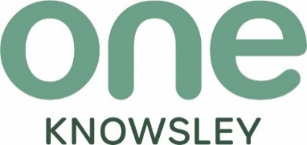

Email: info@oneknowsley.org
Phone: 0151 489 1222
Website: oneknowsley.org
One Knowsley, Registered Charity No 701955
Limited by Guarantee Registered in England and Wales
Registered Company No 2401660
One Knowsley, The Courtyard, Court Hey Park, Roby Road, Huyton, Knowsley, L16 3NA

